* Understand Agriculture Cycle

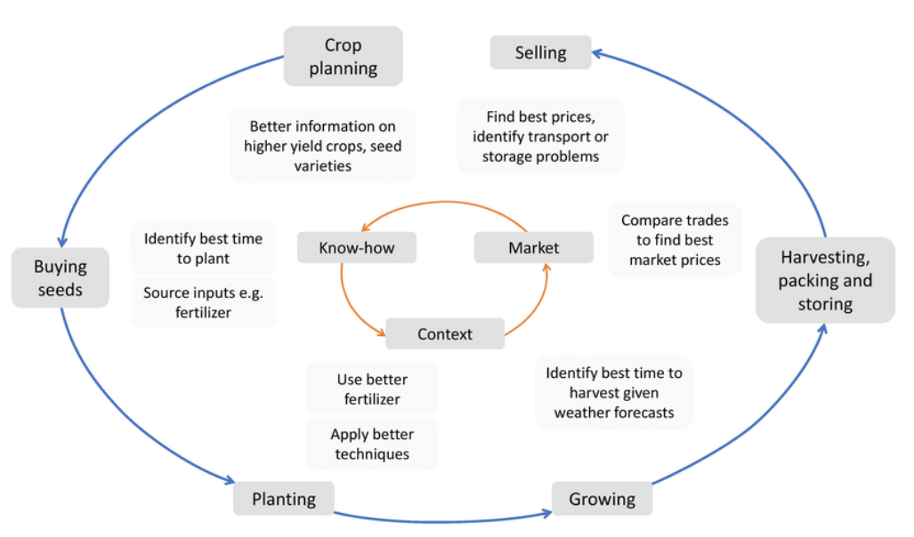

Reference [1]

The main steps for agricultural practices include preparation of soil, sowing, adding manure and fertilizers, irrigation, harvesting and storage.

* Classcification Of Crops

1. Cereals
2. Vegetables and melons
3. Fruit and nuts
4. Oilseed crops
5. Root/tuber crops with high starch or inulin content
6. Beverage and spice crops
7. Leguminous crops
8. Sugar crops
9. Other crops

* Factors affect crop Yield

The four most important factors that influence crop yield are soil fertility, availability of water, climate, and diseases or pests.



[1] Mendes, Jorge & Pinho, Tatiana M. & Santos, Filipe & Sousa, Joaquim & Peres, Emanuel & Cunha, J. & Cunha, Mario & Morais, Raul. (2020). Smartphone Applications Targeting Precision Agriculture Practices—A Systematic Review. Agronomy. 10. 855. 10.3390/agronomy10060855.

[2]<http://www.fao.org/fileadmin/templates/ess/documents/world_census_of_agriculture/appendix3_r7.pdf>